**4Risk Summary Sheet**

**Background**

This document summarises how to do the following on 4Risk:

* How to view the UoE operational risk register report
* How to edit a risk
* How to add a risk
* How to add a progress/information update
* How to delete a risk

**Access**

You can access 4Risk by clicking on this link: [4Risk](https://eur02.safelinks.protection.outlook.com/?url=https%3A%2F%2Fuoeriskmanagement.insight4grc.com%2Fdashboard&data=05%7C02%7C%7C8bcda6c6bdbd4497d71408dc73f5dcff%7C2e9f06b016694589878910a06934dc61%7C0%7C0%7C638512747020027293%7CUnknown%7CTWFpbGZsb3d8eyJWIjoiMC4wLjAwMDAiLCJQIjoiV2luMzIiLCJBTiI6Ik1haWwiLCJXVCI6Mn0%3D%7C0%7C%7C%7C&sdata=qkSX0h9KBFLUV71t89lKh4omQ2PMeeyXF8kqXtHwWGo%3D&reserved=0).

**How to view the UoE operational risk register report**

Select the squiggly line from the navigation bar

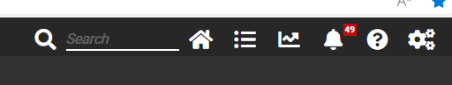

Select the ‘Risk’ option

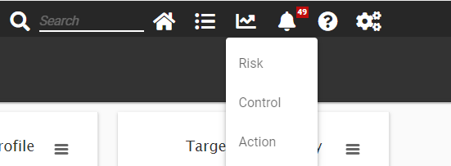

Select the ‘Operational Risk Register and Report – UoE’

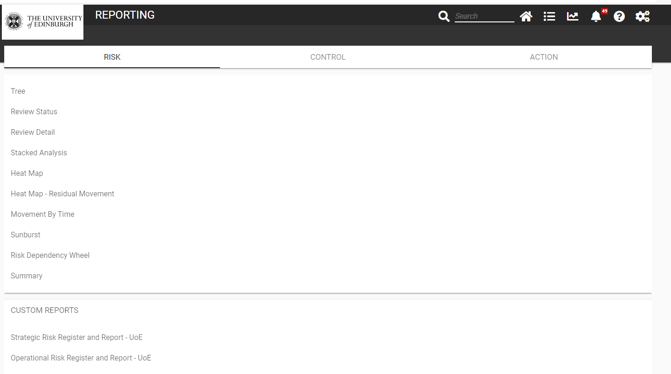

Click on ‘EXPAND TO SET RISK REPORT FILTERS AND OPTIONS’

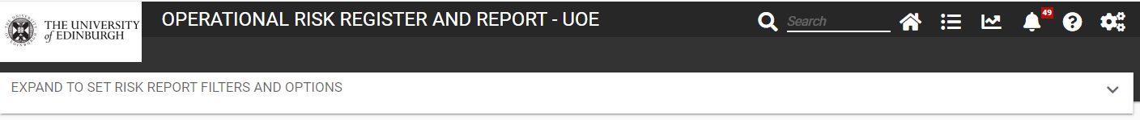

Click on the ‘+’ next to ‘Risk Area – (Determines Access Control)

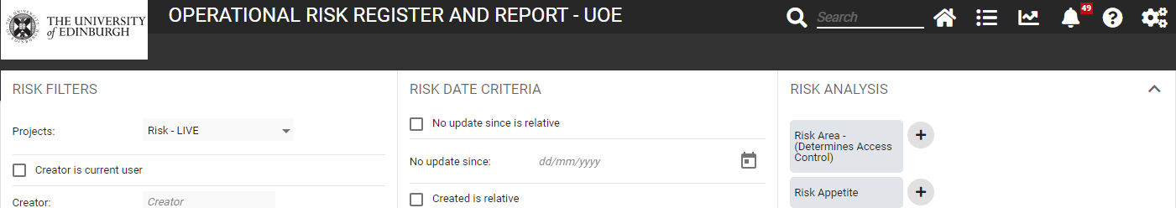

Click on the College/PSG you are in to expand the selection.

Then select the small ‘+’ next to your School / Department / Unit – this will then show the IT / Cyber area for your School / Department / Unit

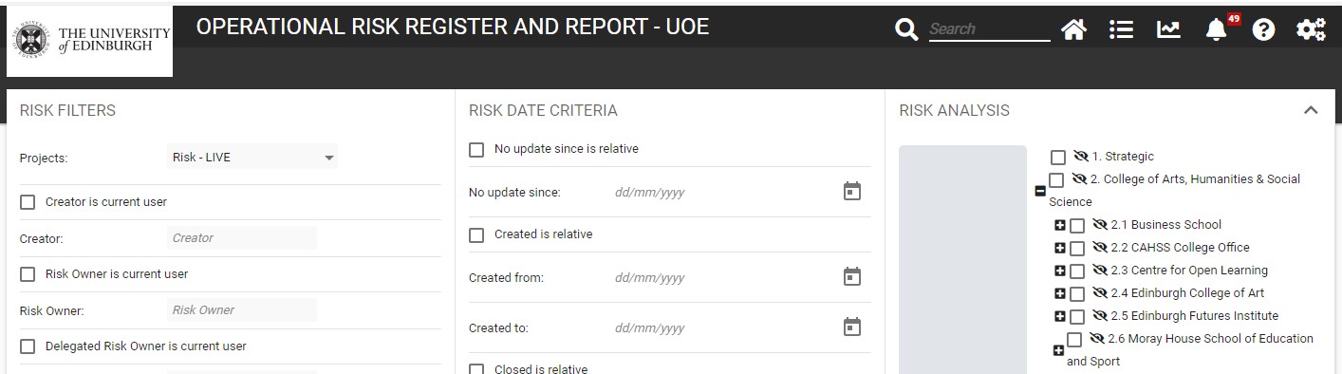

Tick the box for the IT and Cyber Security section in your School / Department / Unit

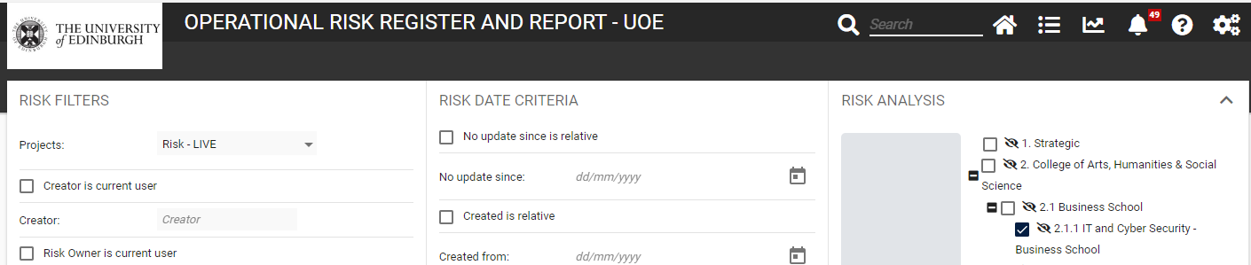

Scroll down until you can see the ‘DONE’ button, and click on this

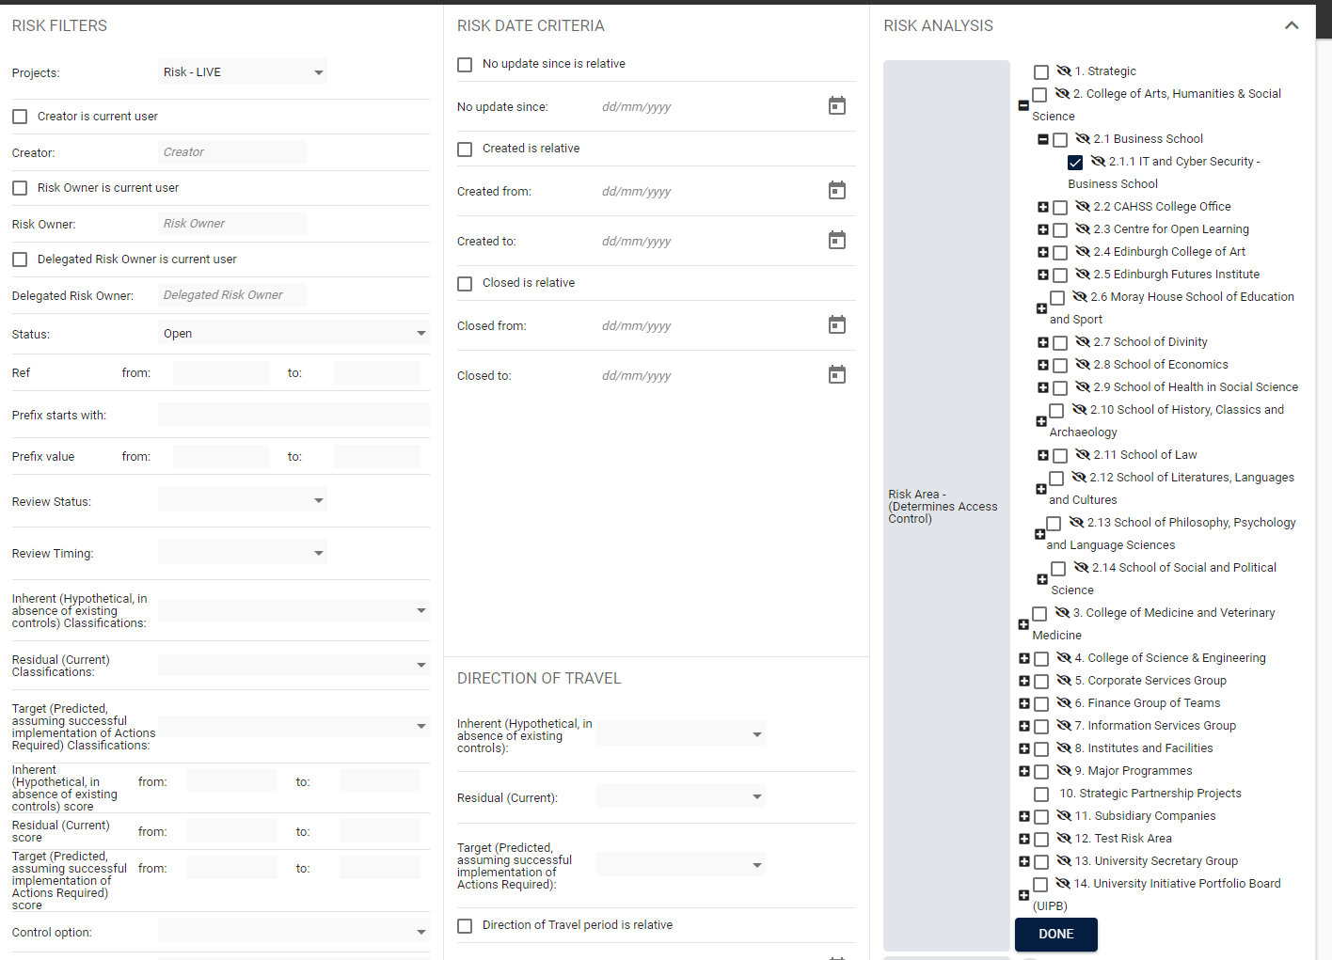

Then click on the ‘RUN’ button at the bottom

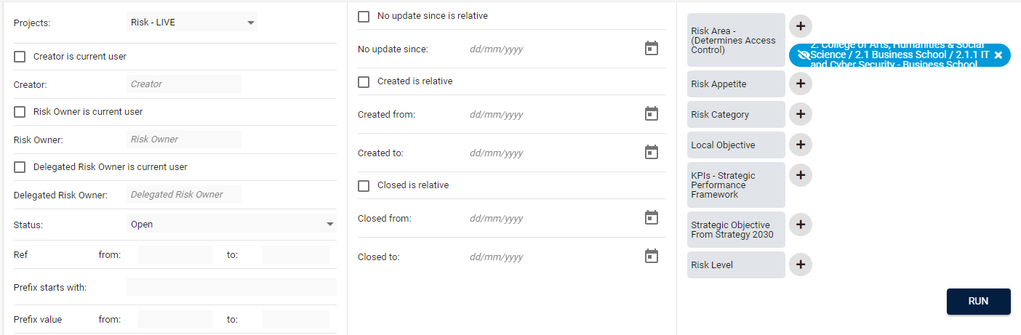

This will show the report on screen.

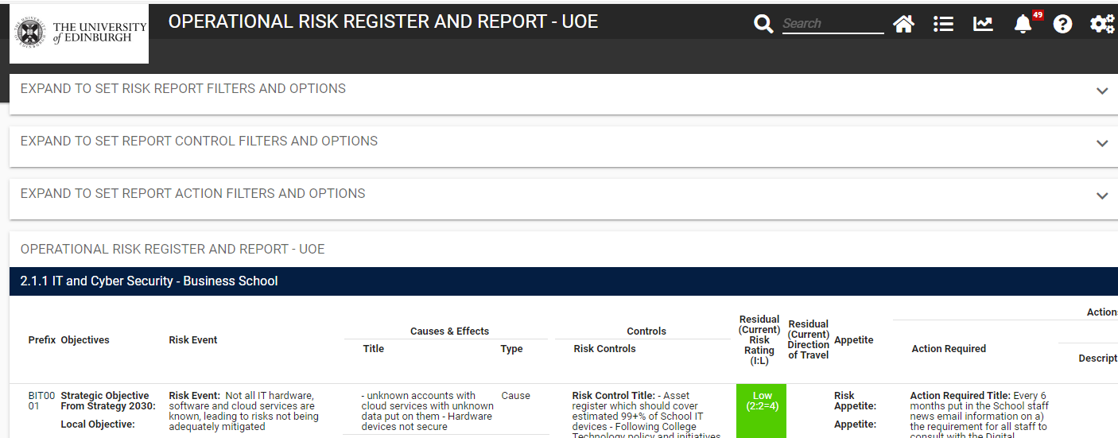

To export the report, scroll right to the bottom of the page, click on ‘EXPORT’ and then select PDF, Excel or Word. PDF is the better of these options in terms of an easy to view document.

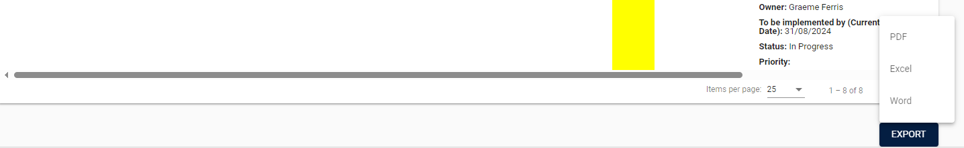

This will bring up the report, with the following format

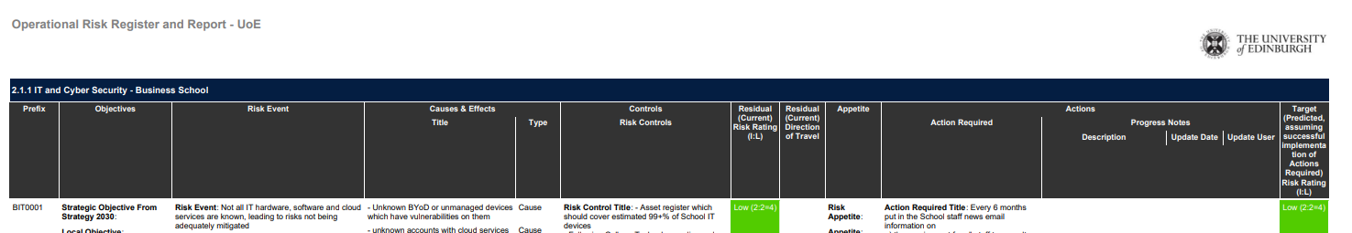

**How to edit a risk**

First of all you need to find the risk. This can be done a number of ways

1) On the **home page** you can select your area in the **‘Risk by Risk Area’** – you will only have access to see the areas that you can view and only those areas that contain at least one risk record will appear. Click on the box with the arrow facing out from the box.

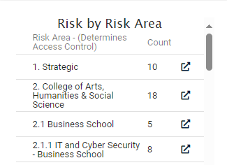

This brings up the risks in that area. Click on the box with the arrow facing out from the box for the risk you want. This opens up the risk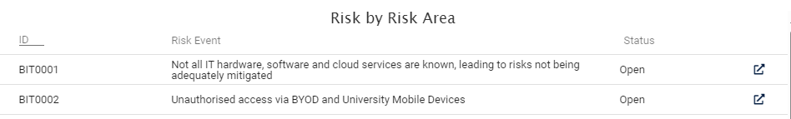

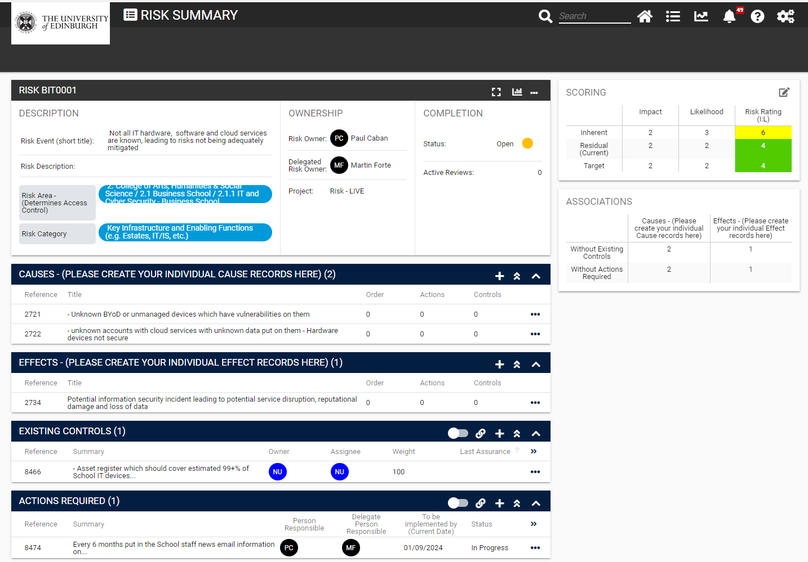

2) You can find out the **risk reference from your risk register**, and insert into the **search field, or do a search on terms in the risk using the search function**

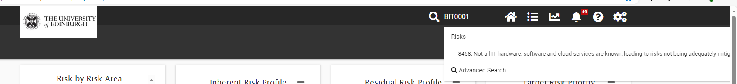

This brings up the risk which you can then click on and it will open the full risk record.

3) Use the **‘navigation’ option** on the top bar



Select ‘Risk’



Click on ‘Filter Criteria’. By clicking on the options on the bar at the top will show those that are

* assigned to you
* owned by you
* created in 4Risk by you
* flagged for you
* or which you have group access to

If you are involved in a number of areas you can refine the search by clicking on ‘Filter Criteria’

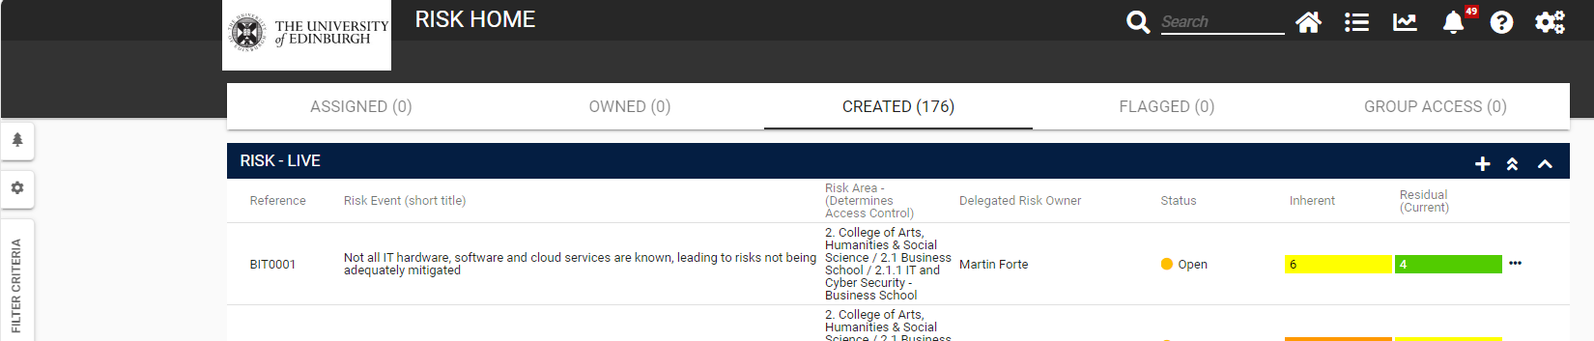

Click on the ‘+’ next to ‘Risk Area – (Determines Access Control)’, select your area, then click ‘Filter’

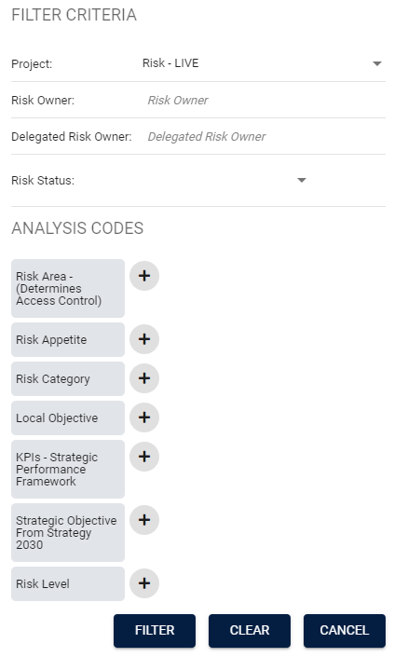

**Editing a risk**

Once you are in the risk you need to go into edit mode to make changes. To go into edit mode click the three dots and then select ‘Edit’

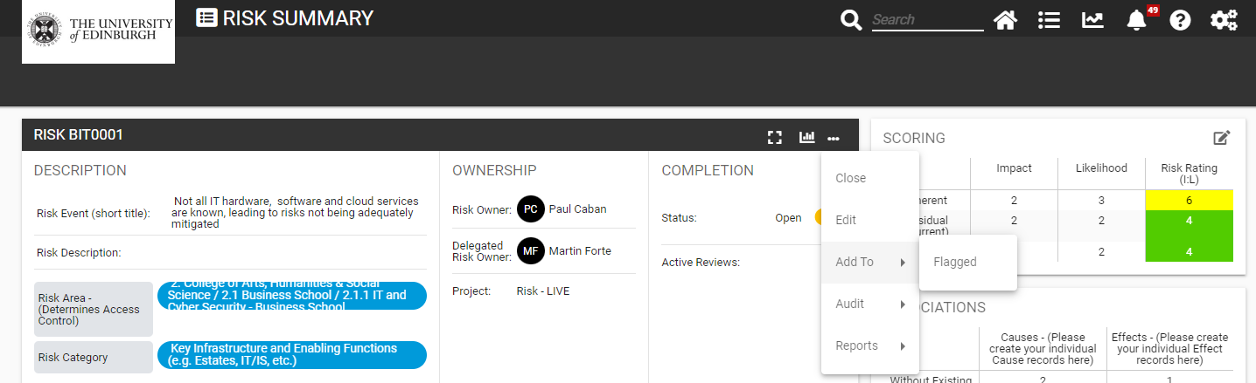

Click on the ‘Save’ button to save your changes.

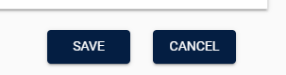

For editing causes, effects, existing controls and actions required, expand the list using the down arrow icon

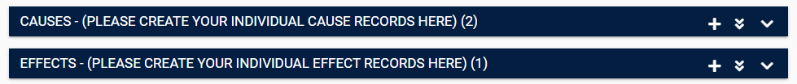

Then click on the relevant item

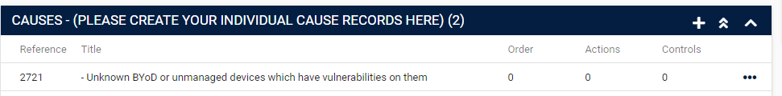

Then click the ‘Edit’ button, make your changes, then click the ‘Save’ button

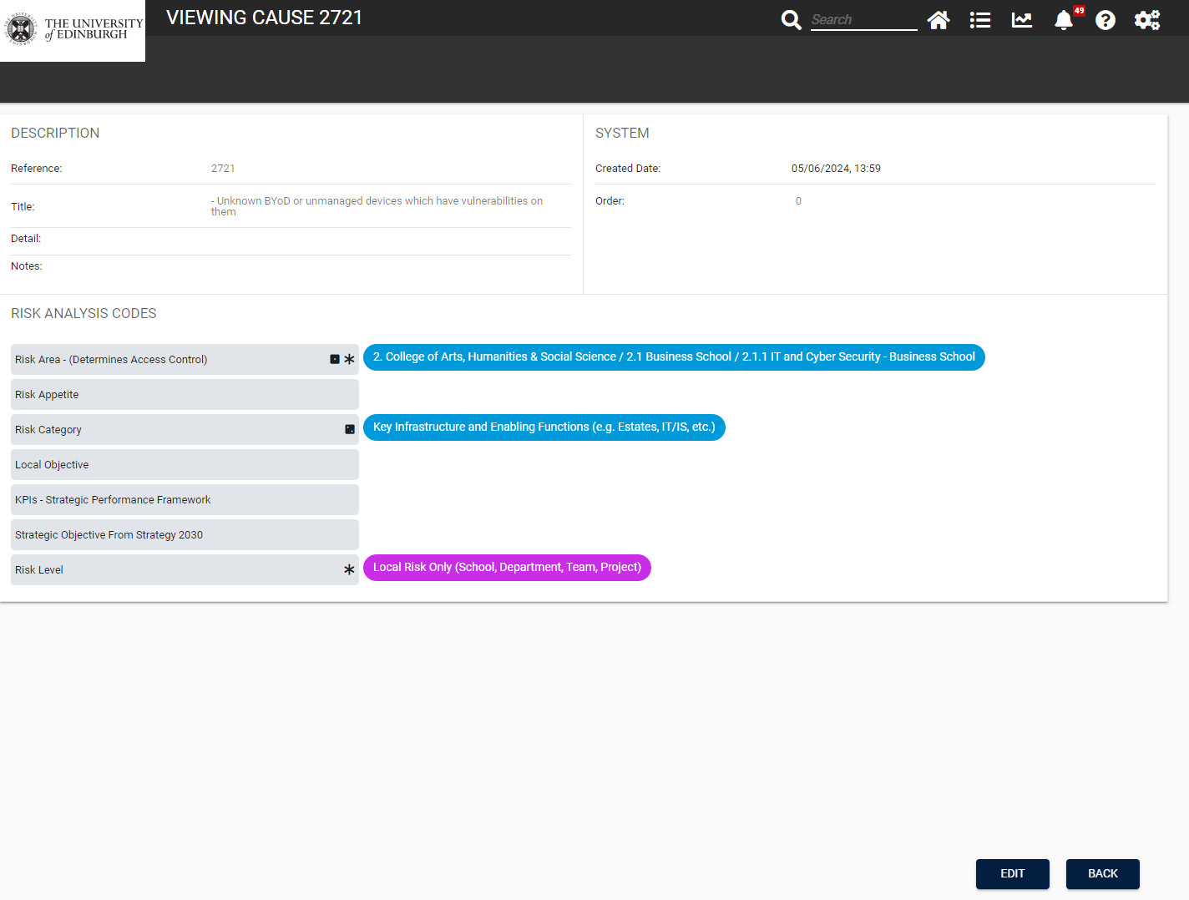

To edit scores, click on the pen in the box icon on the top left, make changes, provide a brief reason for the change, and save

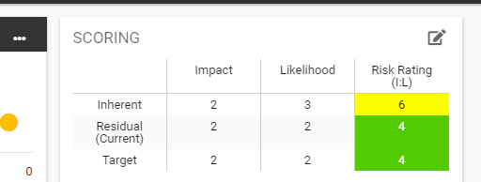

**How to add a risk**

There are a number of ways to do this

1. Click on the ‘Navigation’ icon and then select the ‘Risk’ option

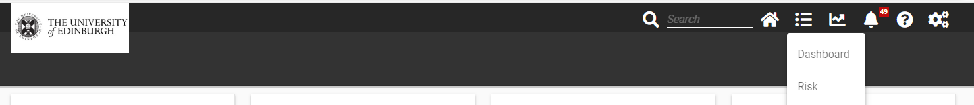

Then click on the ‘+’ right at the bottom of the screen

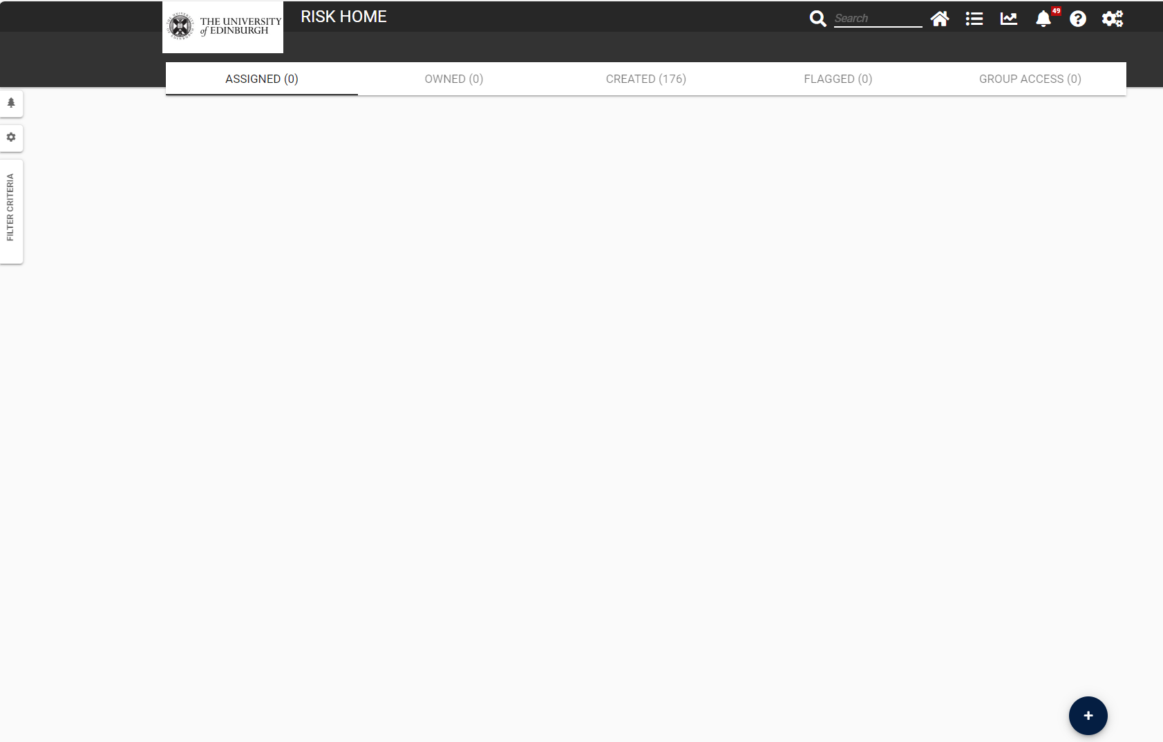

2. Another way to add a risk is, on the same page, to click on the ‘+’ at the top

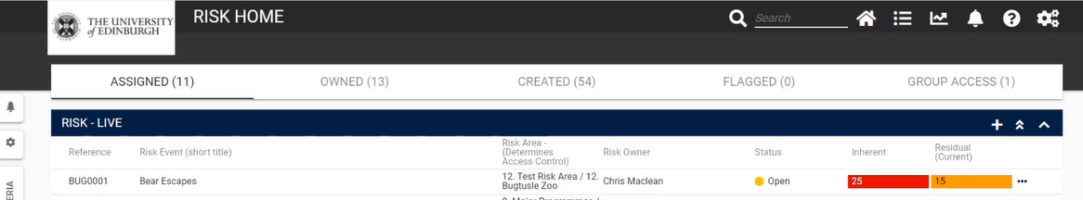

**How to add updates**

There are three types of updates within 4Risk: updates to specific *Actions Required*, updates to the risk summary record, and updates to specific *Existing Controls*. Note that any updates, once saved, cannot be edited or deleted. If entered in error, create a new update containing the corrected information.

1. Updates to *Actions Required* are perhaps the most important, as they describe progress made against the *Actions Required* you’ve identified, which are ultimately what will reduce the risk. They are used to populate the “Progress Notes” which appear on the system-generated *Operational Risk Register and Report*, to change an action’s status from *Pending*, to *In Progress,* and adjust the *“To be implemented by”* date.

From the Risk Summary page, select the *Action Required* you wish to update:

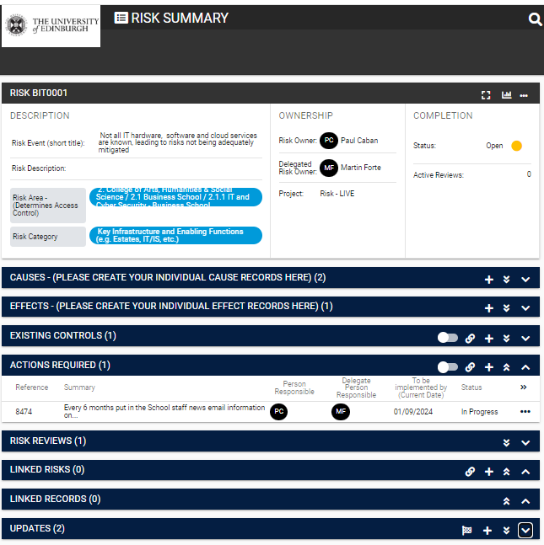

That will take you to the *Action Summary* page. Click on the ‘+’ icon in the *Updates* section at the bottom:

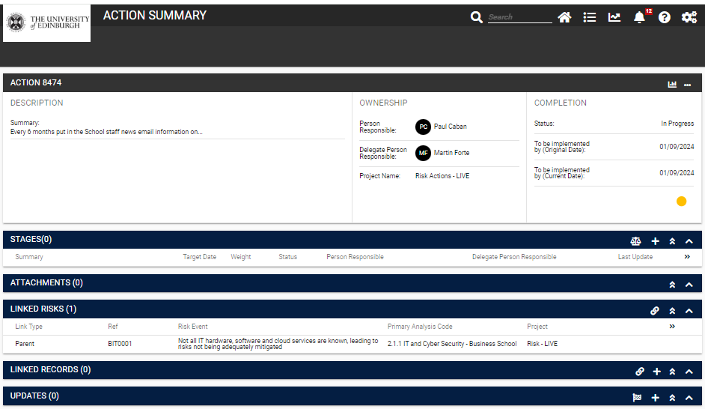

Add a *Description* of the update, identify *Type of Update* as *Information* (to maintain the Action’s status as “Not Started”), or *Progress* (to change the Action’s status to “In Progress”). You also have the option to update the *To be implemented by* date, or to select a new *Delegated Person Responsible*. Click “save”.

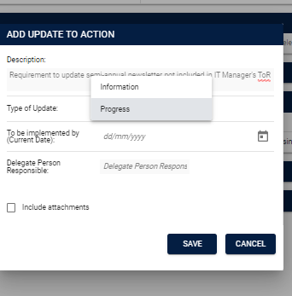

An Action Required can also be updated to “Closed” once *Fully Implemented, Cancelled* or *Superseded*. To Close an *Action Required*, select the “checker flag” icon from the Action Summary’s Update section, provide a brief description of the reason it’s being closed, select *Type of Update*, and click *Save*

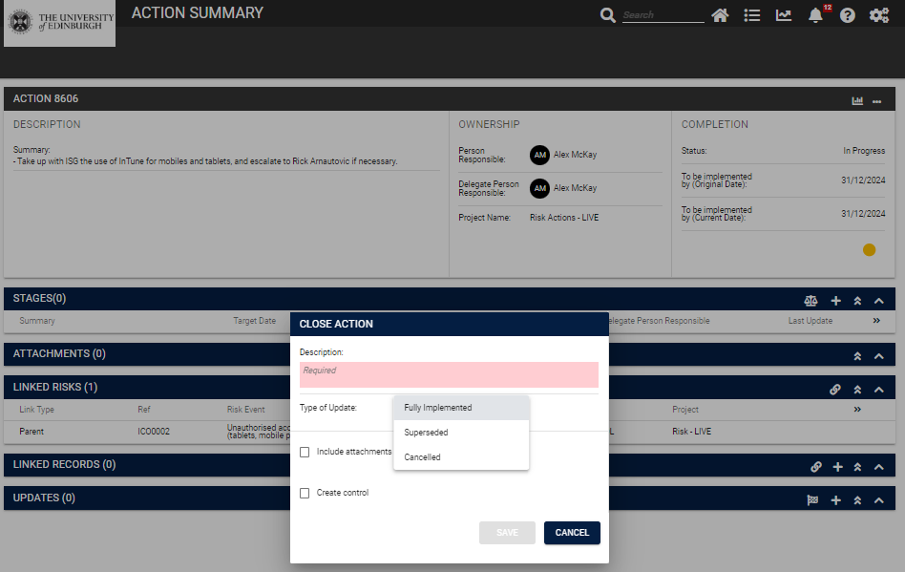

*Actions Required*, once fully implemented, should be your cue to add a new corresponding *Existing Control.*

1. Updates to the Risk Summary record. These are used to highlight occasions when the risk event, causes or impacts have been changed, and/or the score has been adjusted. From the Risk Summary page, click on the ‘+’ icon in the ‘Updates’ section at the bottom

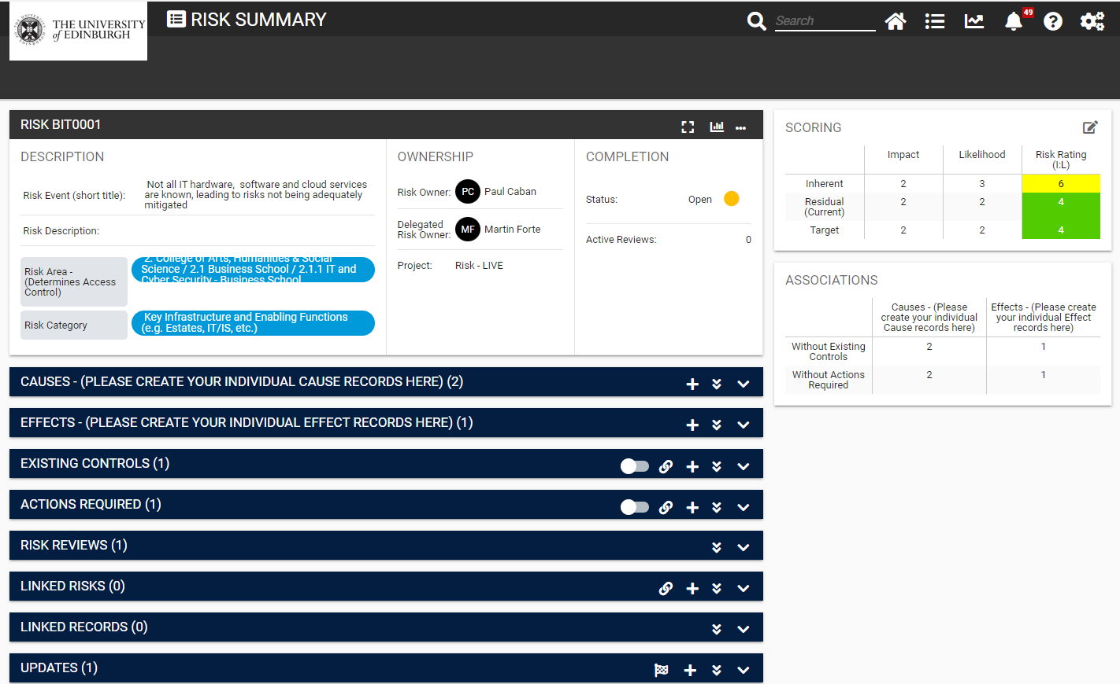

You can then input a general information update (providing additional information) or a progress update (explaining how the risk is generally progressing). Type in a description in the ‘Description:’ box, select the Type of Update (‘Information’ or ‘Progress’), click the ‘Include attachments’ box if you wish to include attachments (and then upload). You don’t need to include the Delegated Risk Owner details. Click save.

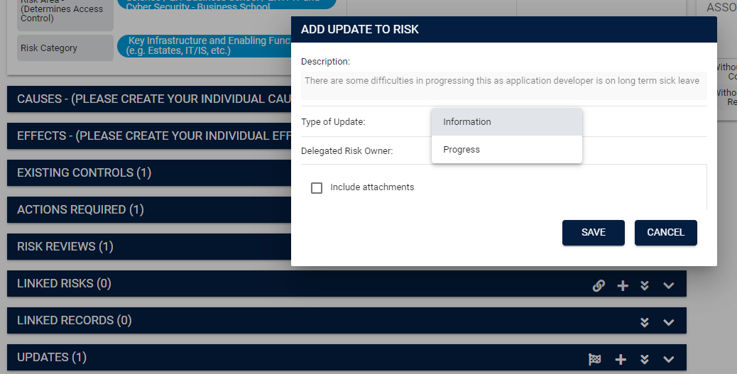

1. Update Existing Controls the same way, by selecting the specific control from the *Risk Summary* page, clicking on the ‘+’ icon in the Updates section at the bottom of the *Control Summary* page, and then providing a description of the update (e.g. “Staff completion of Information Security Essentials course now verified at 85%”)

**To remove a Cause, Effect, Existing Control or Action Required**

To remove a Cause or Effect that no longer applies, an Existing Control that is no longer in place, or Action Required that was cancelled or entered in error, from the Risk Summary page, find the item you want to remove, click the three dots, and select “Remove”.

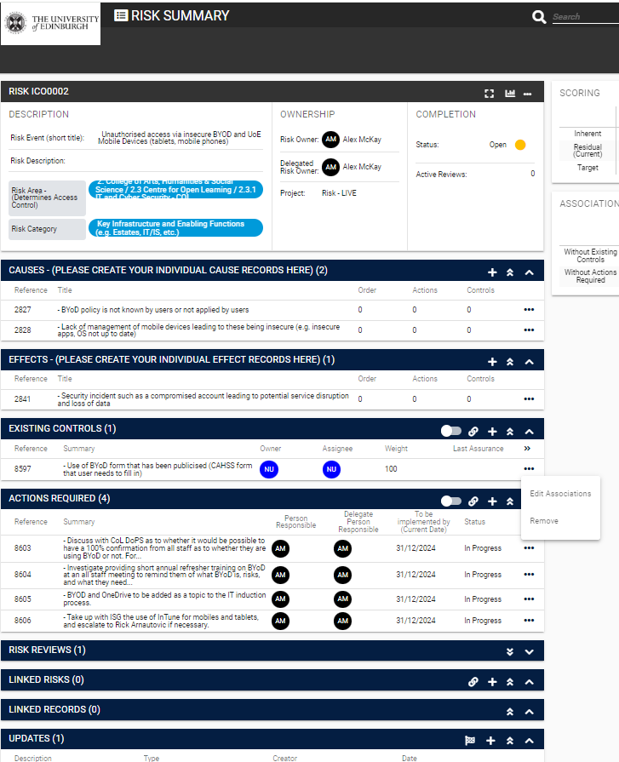

You should typically only remove an Action Required if it has been entered in error. If closing the Action for any other reason, use the Close Action option described in the “Updates to *Actions Required*” paragraph above.

**To close a risk**

Click on the chequered flag in the Risk Summary *Updates* section



This will come up with a dialogue box

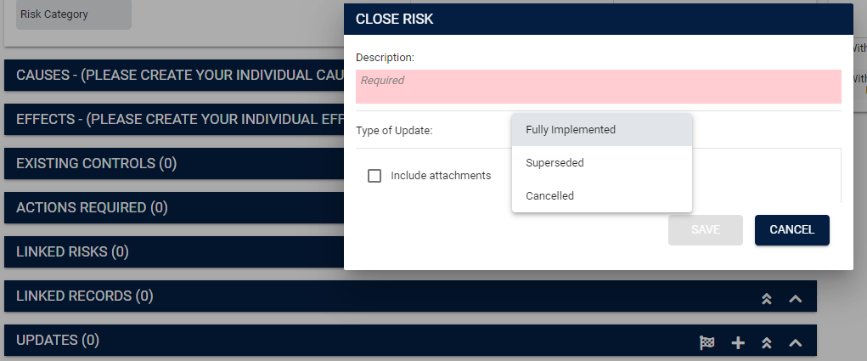

Type in the reason this is being closed, select a ‘Type of Update’ (Fully Implemented, Superseded, Cancelled), add any attachments and then save. This is marked as ‘Closed’ in 4Risk.